


DISCHARGE SUMMARY
{{name}}

Age/gender : {{age}}
Department : Cardiology
Address : {{ad1}}
{{ad2}}
+91 {{mob}}
Admitted {{admit}}

Admission No : {{admision
}}
UMR No : {{umr}}
Ward : {{ward}}
Referred By:
Discharged {{discharge}}

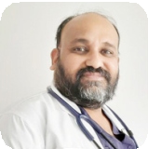
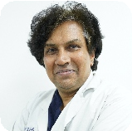


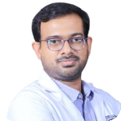
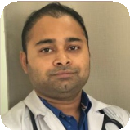






Consultants:
Dr. M.S.S Mukharjee MD,DM(Card), DNB (Card)
Dr. Movva Srinivas MD,DM (NIMS)
Dr. Vinod K Unni MD,DM (Cardiology) Dr. R V Venkat Rao MD,DM (NIMS) Dr. T. Vamshidhar MBBS DrNB (CTVS)
Dr. Vikash Kumar Shukla MBBS, P.G.D.C.0 (Cardiologist)

www.thepulseheart.com



Diagnosis:

{{Diagnosis}}
Cross Consultants:

{{cross1}}
{{cross2}}
{{cross3}}
{{cross4}}

Risk Factors / Past History:

{{Riskfactors}}

Treatment Plan:
MEDICATIONS AS ADVICED

www.thepulseheart.com



Chief Complaints or symptoms:

{{ChiefComplaints}}

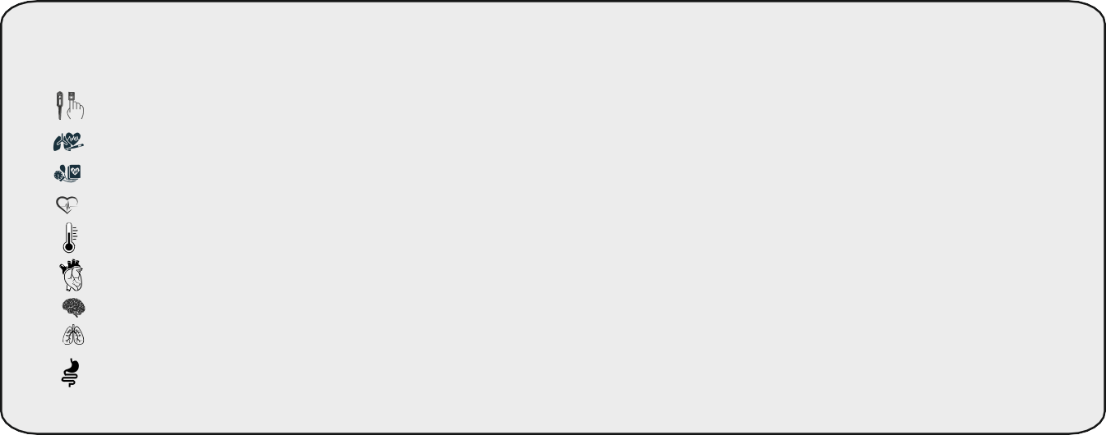
General Examination:

TEMP-{{TEMP}}
BP-{{BP}}
PR-{{PR}}
SPo2-{{SPo2}}
RR-{{RR}}
CVS-{{CVS}}
RS-{{RS}}
CNS-{{CNS}}
P/A-Soft

Investigation:
ENCLOSED

Course in the Hospital:

{{Course}}

www.thepulseheart.com

www.thepulseheart.com

S. NO |  MEDICATION | DOSAGE | FREQUENCY |  TIME OF THE MEDICINE
1 | {{TAB1}} | {{DOSAGE1}} | {{FREQ1}} | {{TOM1}}
2 | {{TAB2}} | {{DOSAGE2}} | {{FREQ2}} | {{TOM2}}
3 | {{TAB3}} | {{DOSAGE3}} | {{FREQ3}} | {{TOM3}}
4 | {{TAB4}} | {{DOSAGE4}} | {{FREQ4}} | {{TOM4}}
5 | {{TAB5}} | {{DOSAGE5}} | {{FREQ5}} | {{TOM5}}
6 | {{TAB6}} | {{DOSAGE6}} | {{FREQ6}} | {{TOM6}}
7 | {{TAB7}} | {{DOSAGE7}} | {{FREQ7}} | {{TOM7}}
8 | {{TAB8}} | {{DOSAGE8}} | {{FREQ8}} | {{TOM8}}
9 | {{TAB9}} | {{DOSAGE9}} | {{FREQ9}} | {{TOM9}}
10 | {{TAB10}} | {{DOSAGE10}} | {{FREQ10}} | {{TOM10}}
11 | {{TAB11}} | {{DOSAGE11}} | {{FREQ11}} | {{TOM11}}
12 | {{TAB12}} | {{DOSAGE12}} | {{FREQ12}} | {{TOM12}}
13 | {{TAB13}} | {{DOSAGE13}} | {{FREQ13}} | {{TOM13}}
14 | {{TAB14}} | {{DOSAGE14}} | {{FREQ14}} | {{TOM14}}
15 | {{TAB15}} | {{DOSAGE15}} | {{FREQ15}} | {{TOM15}}
16 | {{TAB16}} | {{DOSAGE16}} | {{FREQ16}} | {{TOM16}}
17 | {{TAB17}} | {{DOSAGE17}} | {{FREQ17}} | {{TOM17}}
18 | {{TAB18}} | {{DOSAGE18}} | {{FREQ18}} | {{TOM18}}
19 | {{TAB19}} | {{DOSAGE19}} | {{FREQ19}} | {{TOM19}}



Medicines
CONTINUE OLD DIABETIC MEDICATIONS AS EARLIER

Note & Instructions:
REVIEW AFTER 1WEEK WITH CBP, ECG , SR. CREATININE , SR.ELECTROLYTES , RBS REPORTS IN OPD WITH Dr.M.S.S MUKHARJEE (CARDIOLOGY)

When And How To Obtain:

IF ANY EPISODE OF
- SHORTNESS OF BREATHE
- CHEST PAIN
- PANIC ATTACK/SYNCOPAL ATTACK
- .EXPLAINED HIGH RISK OF STENT THROMBOSIS IF ANTIPLATELETS ARE STOPPED
- .EXPLAINED THE RISK OF INSTENT RESTENOSIS OR STENT THROMBOSIS DURING THE 1ST YEAR

IN EMERGENCY CONTACT IMMEDIATELY DR.KRANTHI KUMAR -9949996644
FOR APPOINTMENTS CALL 8886688063 MIYAPUR( 9:30AM TO 3PM)

Medical Officer
Dr.M.S.S MUKHARJEE
MD,DM (NIMS), (CARDIOLOGY)
Sr. CONSULTANT CARDIOLOGIST




Created By DUTY DOCTOR Modified By DUTY DOCTOR

www.thepulseheart.com

